Due on Tuesday, April 17, 2012

Things Fall Apart
Jigsaw reading

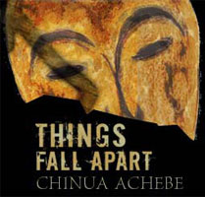

- Everyone must read three chapters and answer the reading questions for the chapters.
- Everyone must answer questions in complete sentences and to the best of your abilities.
- If you experience any difficulty, you must seek Ms. Youssef’s advice via email before Saturday, April 14.
- You also must complete the Chapter Guide for each chapter.
- Each guide must be completed after you read EACH chapter.
- So, you must stop at the end of each chapter and process it with the Guide questions.

I, __________________, am responsible for the following Chapters: ______ ______ ______.

Signature of commitment: __________________
Date of commitment: __________________

ONLY sign in this box when packet is complete.

Signature of completion:__________________
Date of completion: __________________
THINGS FALL APART Chapter Guide
Chapter: ___________ Page ____ - _____
What happens?
7-10 bullet points about plot

Characters
Which characters are present in this chapter? What happens with them? What does this tell us about the characters?

Important Quotes  - Choose 2-3 significant quotes from each chapter.  Significance  - Analyze the significance of these quotes. What do they illuminate about the theme? [Feel free to attach a separate sheet for the quotes/significance.) |  |  | Quotes | Significance
Questions that I have about prior chapters…
Questions that I have about what’s coming next…
My prediction for the end is that…

